

Student Wellbeing Policy

Rationale

*‘Student wellbeing is integral to learning excellence and ultimately to overall health and life success. A positive sense of wellbeing supports a base for rich learning that enables young people to flourish’.*

(Horizons of Hope, Wellbeing)

Learning is enhanced through a healthy, safe and happy environment that ensures that students develop positive behaviours and attitudes towards themselves, others and their learning. Student wellbeing is the responsibility of all members of staff at St Benedict’s. To manage and monitor student behaviour is a consistent and fair manner, School Wide Positive Behaviour Support is implemented throughout the school.

At St Benedict’s, we are committed to upholding transparent Child Safety Standards. As a result, our approach towards the protection of children is all encompassing. We are resolutely committed to ensuring that all those engaged in working with our school community promote the inherent dignity of children and young people, and their fundamental right to be respected and nurtured in a safe school environment. This approach is grounded in a Catholic tradition which celebrates the sanctity and unique dignity of each human being.

Purpose

The purpose of this policy is to:

* Provide students with the opportunity to develop the skills, knowledge, values and attitudes that will enable them to participate fully and effectively in society and the workplace
* Provide an environment that promotes a healthy self-esteem, confidence and a sense of responsibility for self
* Provide experiences whereby students gain a feeling of self worth, develop confidence in their identity and grow toward self-discipline
* Provide a school environment in which all students are able to participate and feel safe, welcomed and valued for their contribution and effort
* Develop positive relationships and connectedness among teachers, students, and parents
* Provide an inclusive approach to teaching and learning
* Implement our whole school behaviour expectations of respect, responsibility, resilience, safety and support

Implementation

Student wellbeing relates to the development, implementation and evaluation of a whole school approach to student wellbeing with a focus on primary prevention, early prevention, intervention and restoring wellbeing.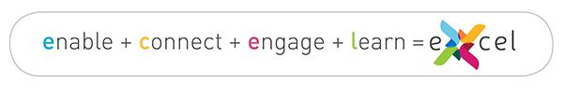

eXcel affirms Catholic Education Melbourne’s ongoing commitment to supporting ‘rich, deep and varied learning experiences’ for our students, so that they may develop as optimistic, resilient young people of faith, ready to be effective members of community, contributing to and enriching the world around them. eXcel builds on Catholic Education Melbourne’s Horizons of Hope education framework.

1. The Learning Program

Within the Victorian Curriculum, the Personal and Social capability focuses on the recognition and expression of emotions, the development of resilience, and the appreciation of diversity of gender, age, language, culture and religion. Students explore the importance of a range of social relationships, including within families, peer groups and the community. They are also enabled to identify and manage emotional responses in a range of contexts.

Learning in Personal and Social capability is strongly connected to many other areas of the curriculum. Health and Physical Education, in particular, enables students to develop knowledge of recognition of personal qualities, awareness of identity and establishment and maintenance of respectful relationships.

1. Relationships

St Benedict’s believes that it is important for all children to establish meaningful relationships with fellow students, parents and staff. The ways in which people interact with each other impacts significantly on each person’s sense of self-worth, belonging and wellbeing. The fostering of high quality, positive interpersonal relationships among staff, students, and parents is a responsibility shared by everyone. The school fosters the emotional, physical and psychological safety of each individual and ensures the development of the whole person.

St Benedict’s supports an inclusive approach which responds to and respects the diversity of each person. It supports and develops all students, so that they may enter the world with a sense of hope, purpose and dignity, collaboration, compassion, diversity, inclusiveness and where a sense of community is embraced.

1. Expectations

At St Benedict’s, each person has the right to expect a strong sense of wellbeing, respect, belonging, security and communication opportunities to enhance their health and wellbeing. Any form of bullying is considered anti-social and unacceptable. Emotional wellbeing is nurtured and restorative processes are practiced when dealing with conflict. The fostering of high quality interpersonal relationships among staff, students and parents is a shared responsibility. The School Wide Positive Behaviour Support Framework is enacted at St Benedict’s.

1. Specialist Support

Student Wellbeing is linked with Student Services. This support provides staff, students and parents with the support needed to meet the individual needs of students. Student Support takes a focus on assisting staff to meet the behavioural, academic, emotional and social needs of all students, in particular those with special social, emotional, learning and/or behavioural needs.

Specific Strategies

St Benedict’s is committed to developing and nurturing an effective whole school approach to student wellbeing. To manage and monitor behaviour in a consistent and fair manner, the following strategies are implemented:

* Social and Emotional Learning (SEL) is a major teaching and learning focus across the school
* The use of a SEL planner
* School Wide Positive Behaviour Support behaviour expectations (see Appendix One)
* Think Sheets used as needed (see Appendix Two)
* Positive relationships between students, staff and families
* Creating positive partnerships with families
* Encouraging student voice through our Student Representative Council
* Upholding Child Safety standards (see policy)
* Understanding of equality through the Respectful Relationships program
* Student Leadership
* Structured lunchtime activities
* Personalised Learning Plans (PLPs) where required

**Evaluation**

This policy will be reviewed and evaluated as part of our four year review cycle.

Appendix One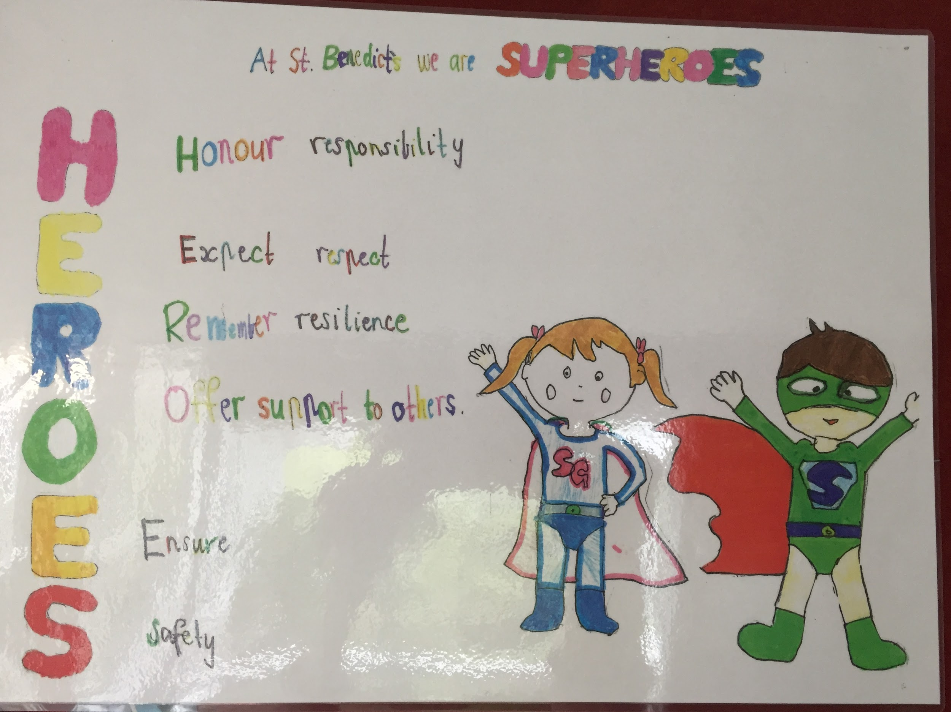

Appendix Two

